**DAILY ONLINE ACTIVITIES SUMMARY**

|  |  |  |  |  |  |  |  |  |
| --- | --- | --- | --- | --- | --- | --- | --- | --- |
| **Date:** | **20-05-2020** | | | | | **Name:** | **Sushmitha b poojary** | |
| **Sem & Sec** | **6b** | | | | | **USN:** | **4AL17CS103** | |
| **Online Test Summary** | | | | | | | | |
| **Subject** | | **SSCD** | | | | | | |
| **Max. Marks** | | **30** | | **Score** | | | **09** | |
| **Certification Course Summary** | | | | | | | | |
| **Course** | **PYTHON FOR MACHINE LEARNING** | | | | | | | |
| **Certificate Provider** | | | **greatlearning** | | **Duration** | | | **2:30hr** |
| **Coding Challenges** | | | | | | | | |
| **Problem Statement:** Write Python Program to Reverse a Given Number | | | | | | | | |
| **Status: completed** | | | | | | | | |
| **Uploaded the report in Github** | | | | | **yes** | | | |
| **If yes Repository name** | | | | | **<https://github.com/Sushmithabp/report3>** | | | |
| **Uploaded the report in slack** | | | | | **yes** | | | |

Online test details: 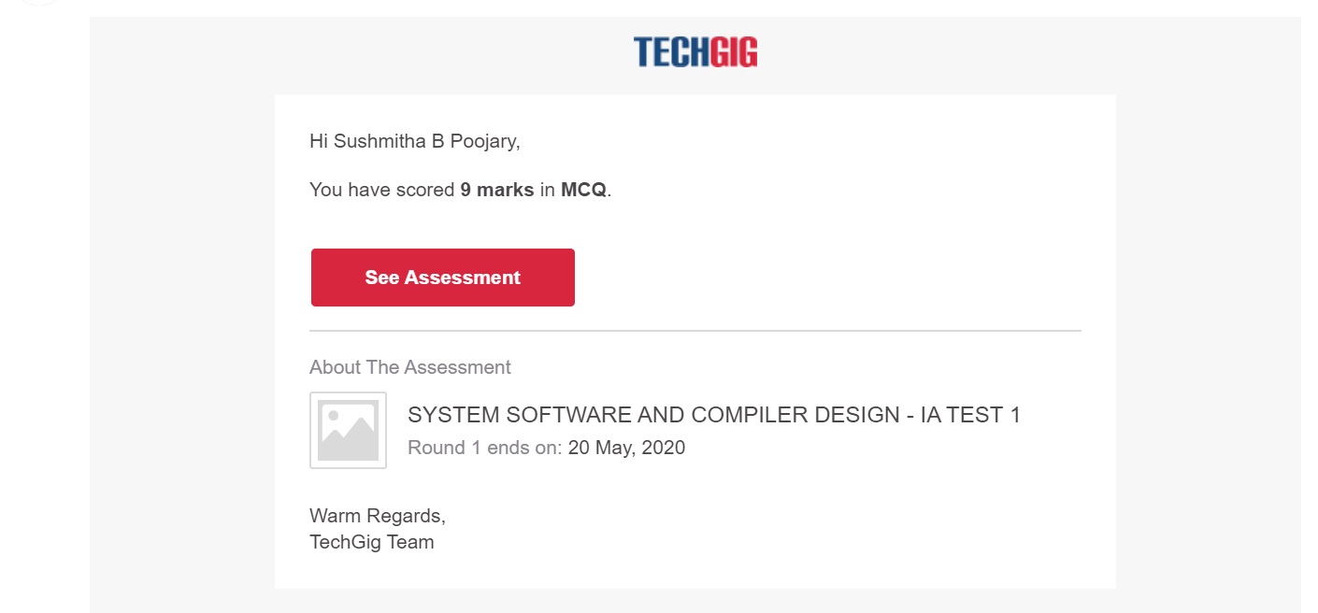

Certification course details:

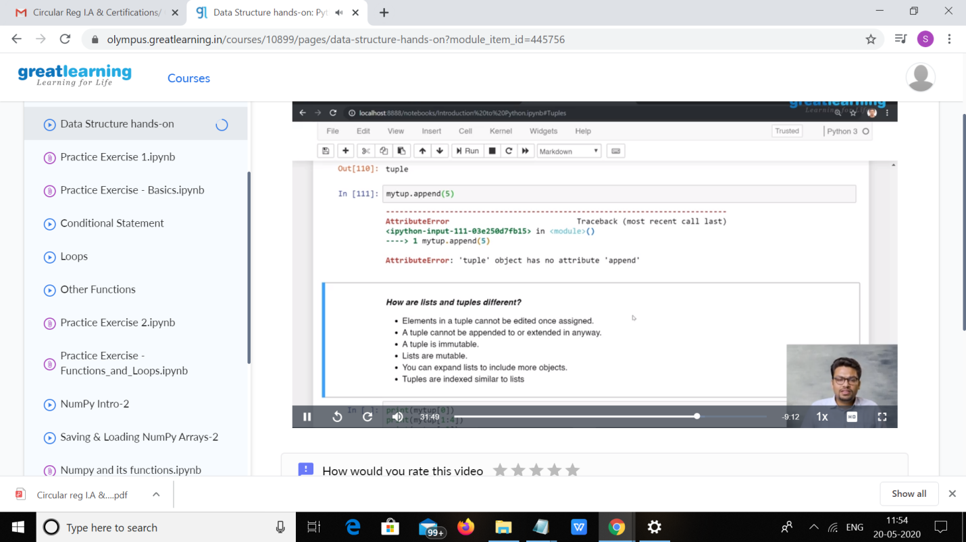

Coding challenges details:

1. Write a C Program to Reverse a Linked List in groups of given size.

Test Case 1:  
If a linked listis: 1 → 2 → 3 → 4 → 5 → 6 → 7 → 8  
The value of size k is 2  
Then the linked list looks like: 2 → 1 → 4 → 3 → 6 → 5 → 8 → 7

Test Case 2:  
If a linked listis: 1 → 2 → 3 → 4 → 5 → 6 → 7 → 8  
The value of size k is 3  
Then the linked list looks like: 3 → 2 → 1 → 6 → 5 → 4 → 8 → 7

#include<stdio.h>

#include<conio.h>

#include<stdlib.h>

typedef struct node

{

int data;

struct node *next;

}node;

void reverse(node *head)

{

if(head == NULL)

return;

if(head -> next == NULL)

return;

reverse(head->next);

head->next->next = head;

head->next = NULL;

}

node *swap_in_a_group(node *start , int k)

{

node *p , *q ,*new_start , *temp;

int cnt;

p = start;

cnt = 0;

while(cnt != k-1)

{

if(p->next == NULL)

{

return start;

}

p = p->next;

cnt++;

}

new_start = p;

q = new_start;

while(1)

{

p = start;

temp = q->next;

if(temp == NULL)

{

reverse(p);

return new_start;

}

q->next = NULL;

q = temp;

start = temp;

cnt = 0;

while(cnt != k-1)

{

if(temp->next == NULL)

{

reverse(p);

p->next = q;

return new_start;

}

temp = temp->next;

cnt++;

}

reverse(p);

p->next = temp;

q = temp;

}

return new_start;

}

int main()

{

int a , i , n , cnt , k=4 , flag = 1;

node *p,*q,*start;

printf("Enter the number of nodes");

scanf("%d",&n);

printf("Enter all the nodes \n");

p = (node*)malloc(sizeof(node));

scanf("%d",&a);

p->data = a;

p->next = NULL;

start = p;

for(i=1;i<n;i++)

{

q = (node*)malloc(sizeof(node));

scanf("%d",&a);

q->data = a;

q->next = NULL;

p->next = q;

p = p->next;

}

printf("\n Enter K ");

scanf("%d",&k);

printf("\n swapped list==");

p = swap_in_a_group(start , k);

while(p!=NULL)

{

printf("%d ",p->data);

p = p->next;

}

return 0;

}

**Output:**

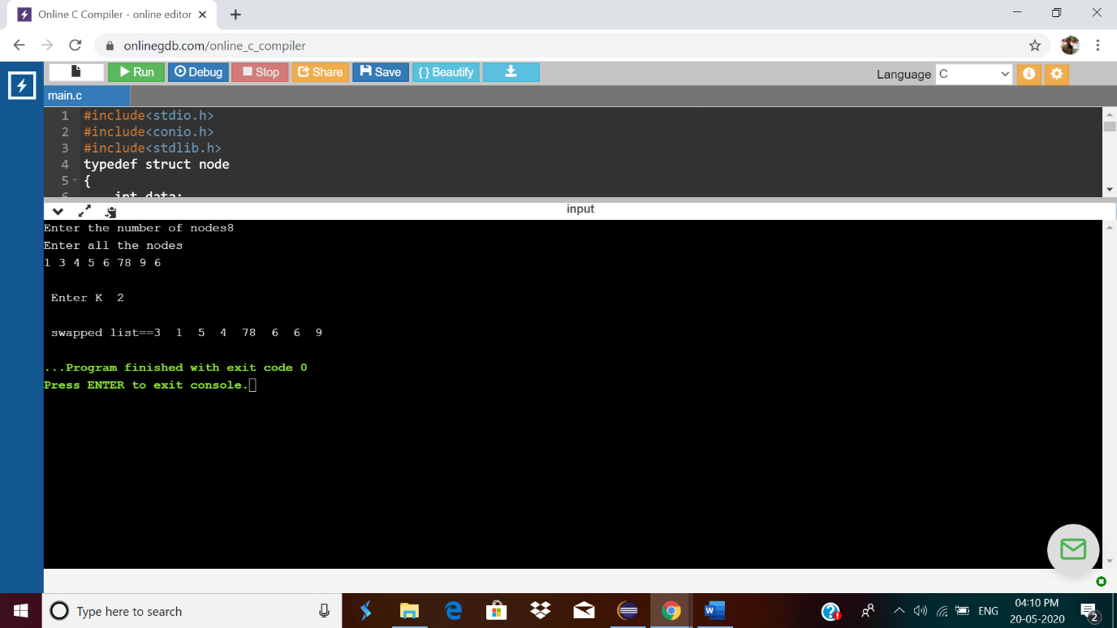

#Write Python Program to Reverse a Given Number

Number = int(input("Please Enter any Number: "))

Reverse = 0

while(Number >0):

Reminder = Number %10

Reverse = (Reverse *10) + Reminder

Number = Number //10

print("\n Reverse of entered number is = %d" %Reverse)

output:

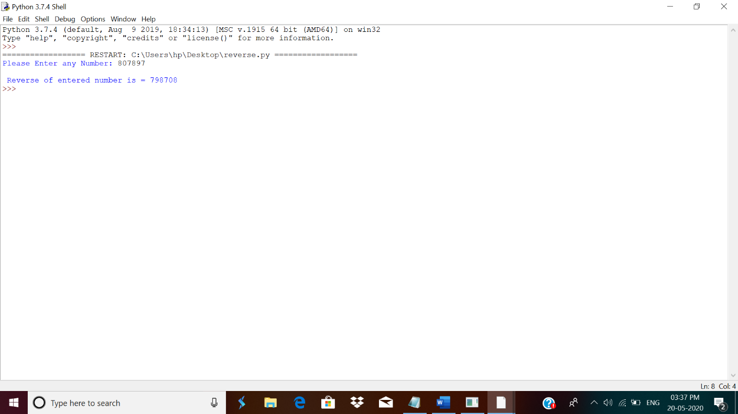

5. Python Program to Exchange the Values of Two Numbers using ^ (exclusive or operator)

x=int(input("Enter value of x: "))

y=int(input("Enter value of y: "))

x = x ^ y;

y = x ^ y;

x = x ^ y;

print ("After Swapping: x = ", x, " y =", y)

**Output:**

